Associate Software Engineer Coding Challenge

Zendesk Ticket Viewer

Zendesk is a customer service tool that allows the creation and management of support tickets. Your company needs you to build a Ticket Viewer that will:

* Connect to the Zendesk API
* Request all the tickets for your account
* Display them in a list
* Display individual ticket details
* Page through tickets when more than 25 are returned

Non-functional requirements:

* Include a README with installation and usage instructions
* The UI can be browser-based or CLI (see example output below)
* The amount of data you display in the ticket list view and the single ticket view is up to you
* How you format and display the ticket data is up to you, just ensure it is easy to read
* The Ticket Viewer should handle the API being unavailable
* We need to see you write *at least* a few happy path tests
* Submissions will be accepted up till midnight on Friday 4th May. Any submissions or commits made after this time will be ignored. Submission can be done either:
  + Via Github, Google Drive or Dropbox - email the link to [mwoodard@zendesk.com](mailto:mwoodard@zendesk.com) Ensure the repo is public. *This is the preferred method of submission*. Meaningful commits will be looked upon favourably.
  + Via email - zip up the project and email to [mwoodard@zendesk.com](mailto:mwoodard@zendesk.com)
  + Please be aware: Gmail blocks the following file types (so please use the above):
    - .ADE, .ADP, .BAT, .CHM, .CMD, .COM, .CPL, .DLL, .DMG, .EXE, .HTA, .INS, .ISP, .JAR, .JS, .JSE, .LIB, .LNK, .MDE, .MSC, .MSI, .MSP, .MST, .NSH .PIF, .SCR, .SCT, .SHB, .SYS, .VB, .VBE, .VBS, .VXD, .WSC, .WSF, .WSH

Criteria for Assessment:

* Meets requirements:
  + No extra features are added.
  + All required features have been attempted.
* Displays some knowledge of application design:
  + Separation of concerns.
  + Simplicity.
* Handles basic errors:
  + Displays a friendly error message if the API is unavailable or the response is invalid.
  + Tells the user something is wrong if there is a program error.
* Includes tests.
* UI is easy to use and displays ticket results clearly.
* Code demonstrates:
  + Consistency.
  + Adherence to common standards.

Getting Started

* Sign up for a free trial with Zendesk: [https://zendesk.com/](https://github.com/). You’ll need to pick an account name. **Take note of this, you’ll need it later.**
* Take a look at the Zendesk Ticket API Documentation: [https://developer.zendesk.com/rest_api/docs](https://developer.zendesk.com/rest_api/docs/core/tickets). You’ll find instructions on how to connect to the API and make requests for tickets.
* We have also sent you a script you can run to populate your account with some data to use for testing.

Gotchas:

* **Do Not Use** Javascript in the browser (running on Node is fine). You won’t be able to successfully complete a GET request as we prevent cross-domain requests.
* Remember that even though the response comes back as JSON format it is still just a string and needs to be parsed to be of any use to you.
* Use basic authentication.

Sample Output

*Note: These are really basic samples only and not to be taken as prescriptive. We encourage you to format the ticket output in your own way.*

Sample CLI

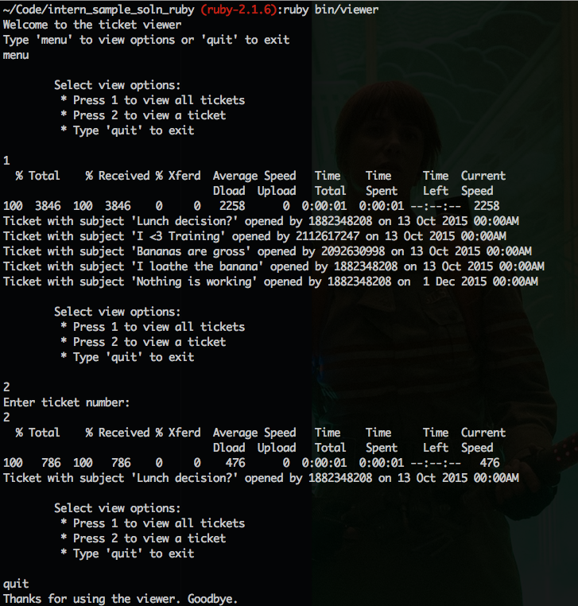

Sample Static Website

